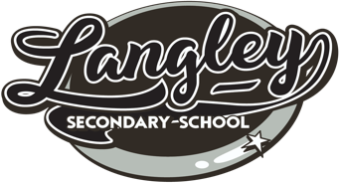
June Conversation
25% of mark for Career Education 9 Name: ___________________

What: A celebration of learning!
The June Conversation is a meeting between a grade 9 student and a teacher. These will occur on June 1st & 2^{nd,} 2020. Each grade 9 student will be scheduled to meet with a teacher for 10 minutes in the old library. The room will be set up with 2 chairs at each of 10 tables, equipped with a computer.

Students will use the provided laptop to log in to their myBlueprint account, receive their paper copy of their Take Our Kids to Work Day assignment (if completed and submitted) and be prepared to talk about each of the 4 parts below for about 2 minutes each.

- Who am I?
- What do you value and care about? What’s important to you?
- What are your strengths?
- What are your areas for growth and improvement?
- What areas of study/work most interest you? What are your favourite subjects or things to learn about in your free time? Who/what inspires you?
- What are your personal interests? Hobbies? Sports?

- Referring to their Core Competencies Portfolio, students will show their 3 reflections and speak about one they feel demonstrates a skill well.

- Referring to their Inquiry Questions Portfolio, students will show their 8 Inquiry Questions (one related to each course subject) and speak about one they are interested in answering and why.

- Referring to their Take Our Kids to Work Day Assignment, students will share where they went and the main thing they learned from that experience.

- Using the Work Habits Self-evaluation, students will conclude what they feel they deserve as their mark.
Why: The June Conversation is a chance to practice speaking about yourself, your strengths and interests in a slightly formal setting. It’s good practice for future education and job interviews. It’s a chance to express who you are with a teacher in the school who may be able to support you, especially if you share a class/club or team. It’s a great way to celebrate who you and how your interests are directing your next steps!

How: The “Be Prepared” Checklist
I have completed…
- The Take Our Kids to Work day assignment and evaluation (copies are still available in the office,
in the gray mailboxes when you first walk in
- 8 Inquiry Questions and 1 reflection
- 3 Core Competency reflections, am prepared to explain one
- What I would like to say for 2 minutes to start the June Conversation
- The “Who am I?” questions above for guidance
- Read the course evaluation and know what is expected
Questions?: Ask any LSS staff member (teacher, SEA, career advisor, etc.) , if they don’t know the answer they will send you to someone who will.

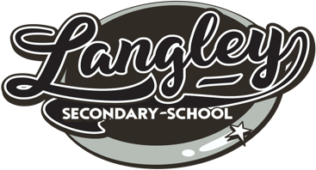
Student Name:_____________________________ Teacher: ______________________________
Career Ed 9 Overall Grade: _______

 | A |  | B | C+ | C | I
June  Conversation | Student prepared and delivered information with outstanding clarity, providing strong examples and understanding of self and the content shared  Artifacts, or additional resources are included to support conversation (i.e. an award/medal or brief video clip of a performance) |  | With good communication and prepared thought, the student:  - Answers “Who Am I” clearly, with examples  - Shares 1 core competency, provides a clear example of how skill was practiced  - Shares about 1 inquiry questions and how to try to answer it  - Shares 1 learning from TOKTW day | With satisfactory communication and thought the student shares about course content | With sometimes satisfactory communication and thought the student communicates course content | Communication and evidence of thought are limited.  Understanding of content is not demonstrated.
Inquiry  Questions | 8 Inquiry questions are uploaded  The student wrote 3 or more themselves (not done as a class or selected from a list) |  | 8 Inquiry Questions are uploaded  Questions reflect personal interests.  - Communicates 1 inquiry question they would like to pursue an answer to | 8 Questions are uploaded, some are inquiry questions | 8 or fewer questions are uploaded, some are inquiry questions. | Questions are lacking in quantity and/or quality
Core  Competencies | 3 reflections demonstrate strong connections and insight to learning and self  1 reflection is shared in the conversation, personal awareness is clearly evident |  | 3 reflections show good and sometime strong connections and insight  1 reflection is shared and student is prepared to talk about it and demonstrates understanding of self | 2-3 reflections show good connections  1 reflection is shared  Student is able to talk about it | 2-3 reflections show few connections  Student struggles to talk about it | 1 or no reflections demonstrate connections or insight
Take Our Kids to Work |  | A | B Evaluations previously completed | C+ | C | Incomplete
Comments:

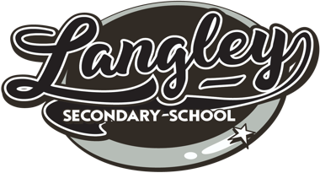
Work Habits
1. I should receive the following work habits mark (please check the boxes):
Excellent | - I demonstrated excellent time management by completing my Career Ed 9 requirements  - I was “on it” and needed no reminding from my teacher  - I independently engaged in the activities and thoughtfully wrote by reflections  - I completed my assignments on or before the deadlines  - I rehearsed with another person what I would talk about for my June Conversation  - I continuously practiced professional behaviour at my June Conversation with attentive and positive body language  - I greeted the teacher with a confident smile and handshake
Good | - I demonstrated good time management by completing my Career Ed 9 requirements.  - I completed my TOKTWD assignment and evaluation by the November deadline  - I used my fixed flex time well and asked for clarification when I needed it  - I engaged in the activities and reflections  - I completed my Inquiry Questions and Core Competency Reflections by the May 1st deadline  - I prepared and practiced what I wanted to talk about for my June Conversation  - I practiced professional behavior at my June Conversation by sitting tall, not fidgeting, arms open  - I greeted the teacher with eye contact and a handshake or smile
Satisfactory | - My time management requires some attention  - Although I completed my work before the deadline, I had to be reminded by my teachers that I was falling behind and I had to rush to complete some activities in time  - I engaged in the activities and reflections with assistance  - I was ready for my June Conversation, but I didn’t practice  - I greeted the teacher with eye contact, a smile or a handshake  - My body language showed that I was attentive and engaged most of the time
Needs Improvement | - I struggled with time management and with completing my Career Ed 9 requirements  - I rarely engaged in the activities or reflections  - I didn’t make eye contact, smile or offer a handshake  - I offered closed body language at my June Conversation (slouching, arms crossed, checking your phone)

2. Which part of this course did you find most challenging/frustrating/unclear?

3. What about this course did you find rewarding/informative/interesting?

