Bibliography
“Band.” Casa de Calexico. Accessed October 27, 2017. http://www.casadecalexico.com/band.
Davidson, Donald, Essays on Actions and Events. Oxford: Clarendon, 2001. https://bibliotecamathom.files.wordpress.com/2012/10/essays-on-actions-and-events.pdf.Cowell, Chip. “Why Museums Are Returning Cultural Treasures.” TED, July 2017, www.ted.com/talks/chip_colwell_why_museums_are_returning_cultural_treasures
Heck, Jr., Richard G. “About the Philosophical Gourmet Report.” Last modified August 5, 2016. http://rgheck.frege.org/philosophy/aboutpgr.php.
Kerouac, Jack. The Dharma Bums. New York: Viking Press, 1958. Reynoldson, Fiona. Key Lash, Scott, and John Urry. Economies of Signs & Space. London: Sage Publications, 1994.
BEFORE YOU SUBMIT CHECKLIST:
- “Bibliography” title is centered at the top of the page
- Citations are left aligned and alphabetically ordered by author last name
- Double-spaced
- Hanging indents are used for any citations that take up more than one line
- Times New Roman, 12-point font
How to Create a Hanging Indent
- Highlight everything on the second line of your citation.
- Right click on your mouse and select the “paragraph” option.
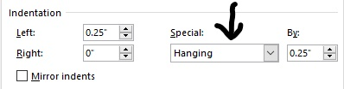
- Under the “indentation” section, in the “special” category, change “none” to “hanging”.
Chicago Style Footnote Citations
The Chicago style of citing sources requires:
- Footnotes for in-text citations
- Bibliography at the end of the paper (info on other side of the page)
How to Insert a Footnote in Word
- Place your cursor after the quote or idea you want to cite.
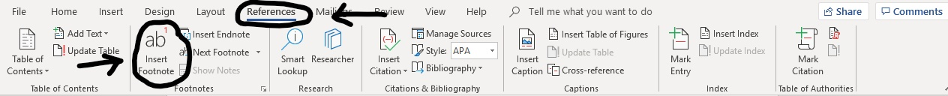
- Go to the references tab in Word.
- Click on insert footnote. A little number will appear where your cursor is. At the bottom of the page, a footnote will appear.
  - The little number should go after punctuation like periods and/or quotation marks.
- Type or copy your citation into the line at the bottom.

What is the difference between a footnote citation & bibliography citation??
For webpages and newspaper articles, the only difference is the order of the author’s name.
Footnote:
1. Firstname Lastname, “Title of Web Page,” Publishing Organization or Name of Website in Roman, publication date and/or access date if available, URL.
Bibliography:
Lastname, Firstname. “Title of Web Page.” Publishing Organization or Name of Website in Roman. Publication date and/or access date if available. URL.

Check out bibme.com for help generating citations.
- Please note that this will only give you a bibliography citation and not a footnote citation. You will have to adjust them.
- These generators can make errors, so make sure to double check the citations

Here’s what a footnote looks like.

